Final Paper:
Examining the Impact of Early Prenatal Care on Preterm Birth Risk
GCH 824
Dr. Krall
Spring 2024

Introduction
With preterm birth rates remaining a persistent challenge in global public health, understanding how prenatal care timing and preterm birth outcomes are connected is important for developing effective strategies and interventions that address the different factors contributing to preterm births. Preterm births are live births occurring before 37 completed weeks of pregnancy and stand as the leading cause of neonatal mortality worldwide.¹ In India, around 13% of all births, amounting to 3.6 million, are preterm.¹
In 2022, preterm births affected roughly 1 in 10 infants born in the United States.² The preterm birth rate declined by 1% in 2022 to 10.4%, following an increase of 4% from 2020 to 2021.² However, racial and ethnic disparities persist, notable with African-American women experiencing a preterm birth rate approximately 50% higher than that of white or Hispanic women, standing at 14.6% compared to 9.4% and 10.1%, respectively.² Reducing infant deaths (<1 y.o.) is a Leading Health Indicator (LHI) in Healthy People 2030 (LHIs address important factors that impact causes of death and disease in the United States).³ It is important to know that infant mortality is one of the indicators with more significant disparities by race/ethnicity, income, and geographic location.⁴
Preterm births and low birth weight ranked as the second leading cause of infant mortality in 2021, with infant mortality referring to the passing of a baby before reaching their first birthday and the infant mortality rate indicating the number of infant deaths per 1,000 live births.⁵ Beyond providing crucial insights into maternal and infant well-being, this rate serves as a significant indicator of societal health.⁵ Pre-pregnancy and prenatal care are essential for preventing complications and educating women about protecting their infants and maintaining a healthy pregnancy.⁶ Through prenatal care, the susceptibility of both the fetus and infant complications is reduced significantly, achieved by abstaining from tobacco smoke and alcohol, ensuring an adequate intake of folic acid, and controlling existing conditions, such as high blood pressure and diabetes.⁶ Ensuring a healthy pregnancy significantly enhances the prospects of a successful birth and early and consistent prenatal care further enhances the likelihood of maintaining a healthy pregnancy.⁶
Cultural competency is crucial in communicating public health content, particularly regarding preterm births and prenatal care, as it fosters inclusive healthcare communication and contributes to improved maternal and infant health outcomes on a societal level. Recognizing the importance of cultural competence in public health communication, especially in prenatal care, suggests that culturally sensitive interventions may enhance the early initiation of prenatal care among diverse populations, forming the basis for our hypothesis. We aim to investigate whether early initiation of prenatal care (defined as entry before 5 months gestation) is associated with a decreased risk of preterm birth among singleton live births in the 2006 U.S. live birth data from the National Center for Health Statistics (NCHS), focusing on the comparison between pregnant women who received early prenatal care and pregnant women who received late prenatal care or no prenatal care at all.

Methods
In this study, we conducted an analysis utilizing data from a subset of the 2006 live birth records in the United States, sourced from the National Center for Health Statistics (NCHS) via the National Vital Statistics System, a collaborative effort between NCHS and individual states, as mandated by law for all births. We will utilize publicly available data that do not contain any personal identifiers. The study aims to assess the association between early initiation of prenatal care (defined as entry before 5 months gestation) and preterm birth (defined as birth between 21 and 36 completed weeks gestation) among singleton live births, comparing individuals who entered prenatal care early or not at all and those who did not enter prenatal care early.
The study population consisted of 80,000 singleton live births born in the United States in 2006. These births were selected from those reported on the 2003 revision of the US Standard Birth Certificate. Following the exclusion of births with missing or invalid data, 55,711 eligible births remained for analysis. The variables included in the dataset displayed diverse demographic characteristics, with ages spanning from 12 to 50 years and identifying with various racial and ethnic backgrounds, including White, African American, American Indian/Alaska Native, Asian, Hawaiian/Pacific Islander, Hispanic, and Multi-racial. Other measured characteristics of the U.S. cohort of singleton live births included maternal smoking during pregnancy stratified by prenatal care status.
The statistical analyses in this study were carried out using a variety of methods to assess associations between early entry into prenatal care or not at all and the risk of preterm birth. First, descriptive analyses characterized the study population. Summary statistics were conducted for variables such as maternal age, maternal race/ethnicity, and maternal smoking during pregnancy, which were stratified by the exposure (early entry into prenatal care or not early prenatal care). Additionally, gestational age at birth and at entry into prenatal care were summarized. Secondly, to investigate the associations between early prenatal care and preterm birth, unadjusted log-risk regression models were fitted to estimate risk ratios (RR) and linear risk models to estimate risk differences (RD). Thirdly, we fit various risk regression models (linear and log-risk) followed by the generation of plots to explore the association between maternal age and preterm birth.
We assessed for potential confounders, including maternal age, maternal smoking during pregnancy, and maternal race/ethnicity through Directed Acyclic Graphs (DAGs), confounding triangles, and statistical modeling. Covariates were chosen for adjustment in the final model based on their impact on the association between early prenatal care initiation and preterm birth by evaluating effect measure modification and the magnitude of the effect. Lastly, sensitivity analyses assessed potential bias arising from outcome misclassification.
All statistical analyses were conducted using SAS Studio OnDemand, SAS version 9.4M7.

Results
Of the 80,000 singleton live births that were reported on the 2003 revision of the US Standard Birth Certificate and after missing and invalid variables were excluded, 55,711 eligible births remained (Figure 1).
Figure 1. Flowchart illustrating exclusions from the total births identified to the final eligible birth population.

The demographic characteristics of the study population are summarized in Table 1.
This includes singleton live births stratified by early and not early prenatal care and key variables such as the number of eligible births, the number of preterm and term births, maternal age (years), maternal race/ethnicity, and maternal smoking status during pregnancy. Summary statistics for gestational age at birth and at entry into prenatal care for all births were also conducted showing a mean gestational age of 38.6 weeks at birth and 3.23 weeks at entry into prenatal care Table 2.
To investigate the association between early prenatal care and preterm birth, we fit unadjusted log-risk regression models to provide risk ratios (RR) and linear risk models to provide risk differences (RD) (Table 3). The data suggests that individuals who entered prenatal care prior to 5 months gestation were 15% less likely to experience preterm birth compared to those who entered prenatal care late or did not enter prenatal care at all (RR=0.85, 95% CI: 0.80, 0.90), with a corresponding RD of -0.019 (95% CI: -0.026, -0.012).
To investigate the association between maternal age and preterm birth, we conducted an analysis using a linear risk regression model. Model 10, Figure 2, which includes a quadratic age variable capturing the increased risk of preterm birth at toward the lower and upper extremes of the range for maternal age, showed estimated risks of preterm birth of 0.157 (95% CI: 0.148, 0.166) for [maternal age 16], 0.103 (95% CI: 0.100, 0.106) for [maternal age 26 (reference)], and 0.136 (95% CI: 0.127, 0.146) for [maternal age 46]. Furthermore, the risk differences (RD) between age group 16 and age group 26 were 0.054 (95% CI: 0.044, 0.064), and between age group 40 and age group 26 were 0.033 (95% CI: 0.022, 0.045) (Table 4).
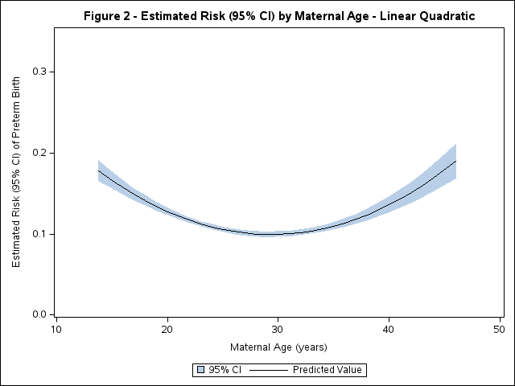
Figure 2. Model 10 - Linear-risk quadratic model showing the estimated risk of preterm birth (95%CI) and maternal age (years).
When we assessed for potential confounders and their impact on the association between early prenatal care initiation and preterm birth, the Directed Acyclic Graph (DAG) and the confounding triangle showed maternal age at conception, maternal smoking during pregnancy, and maternal race/ethnicity to be potential confounders (Figure 3). Our statistical modeling revealed a moderate overall association for maternal race/ethnicity and maternal age, while weaker associations were observed for maternal smoking during pregnancy. Based on the model analysis of confounding of the RR, the covariates chosen to adjust for in the final model (Model 2) were maternal race/ethnicity, maternal smoking during pregnancy, and maternal age (Table 5). After adjustment, the relative risk (RR) of preterm birth associated with early prenatal care initiation remained significant but slightly attenuated at 0.95 (95% CI: 0.89-1.01) compared to the unadjusted estimate of 0.85 (95% CI: 0.80-0.90).
Lastly, analyses assessing potential bias due to outcome misclassification explored sensitivity scenarios from perfect classification to differential misclassification. For non-differential misclassification (scenario 2), the sensitivity and specificity were reduced to 98% and the preterm birth risk among those receiving early prenatal care decreased to 0.82, compared to the corrected RR of 0.85, which biased the results up and towards the null hypothesis. In scenario 6, sensitivity and specificity reductions to 95% and 88% for early care and non-early care groups, respectively, the corrected RR changed to 1.08 which biased the results down and past the null hypothesis (Table 6a and 6). Despite variations in sensitivity and specificity in different scenarios, they illustrate how misclassification of the outcome (preterm birth risk) can lead to biased conclusions about association between the exposure (early prenatal care) and the outcome. The perceived effect of early prenatal care on preterm birth risk can be either underestimated or overestimated.
Discussion
Understanding the relationship between prenatal care timing and preterm birth outcomes is essential for addressing the global public health challenge posed by preterm births. In this study, we aimed to investigate whether early initiation of prenatal care, defined as entry before 5 months gestation, is associated with a decreased risk of preterm births among singleton live births in the 2006 U.S. population. Our findings contribute to the existing literature on this topic and provide insights into potential strategies for reducing preterm births.
Our analysis of 55,711 singleton live births from the 2006 U.S. population revealed several key findings. Firstly, individuals who initiated prenatal care before 5 months gestation were 15% less likely to experience preterm birth compared to those who initiated care late or did not receive prenatal care at all. This association remained significant even after adjusting for potential confounders such as maternal age, maternal smoking during pregnancy, and maternal race/ethnicity. Furthermore, different scenarios, despite varying sensitivity and specificity, demonstrate how misclassifying the outcome (preterm birth risk) can bias conclusions about the link between the exposure (early prenatal care) and the outcome. This can cause the perceived impact of early prenatal care on preterm birth risk to be underestimated or overestimated. Additionally, we found a quadratic relationship between maternal age and the risk of preterm birth, with increased risks observed at both younger and older maternal ages.
Our findings align with the broader public health goal of reducing preterm birth rates, which are a leading cause of neonatal mortality worldwide.¹ The persistent racial and ethnic disparities in preterm birth rates highlight the importance of targeted interventions to address disparities in prenatal care access and quality.⁴ Initiatives aimed at promoting early initiation of prenatal care among at-risk populations could contribute to reducing these disparities and improving maternal and infant health outcomes.
Our findings are also consistent with previous studies that have demonstrated a protective effect of early prenatal care initiation against preterm birth. A study that analyzed 14,071,757 births found that preterm birth rates were higher for African American women when compared to white women and the absence of prenatal care was associated with a 2.8-fold increased relative risk for preterm birth.⁷ By corroborating existing evidence, our study reinforces the importance of prenatal care timing as a modifiable risk factor for preterm birth.
Several strengths characterize our study. Firstly, we utilized a large sample size from a nationally representative dataset, which increases the statistical power and generalizability of our findings. Secondly, we employed rigorous statistical methods, including sensitivity analyses to assess potential bias, and adjusted for relevant confounders, enhancing the validity of our results. Lastly, our study contributes to addressing an important public health issue with implications for maternal and infant well-being.
Despite its strengths, our study also has limitations that warrant consideration. Firstly, as with any observational study, causality cannot be inferred from our findings, and residual confounding may have influenced our results. Secondly, the use of retrospective data limited our ability to assess certain factors, such as the quality of prenatal care received or the correct calculations of gestational age based on the last menstrual cycle. Additionally, the reliance on birth certificate data may introduce misclassification or reporting biases and it is crucial to recognize that different scenarios, despite varying sensitivity and specificity, demonstrate how misclassifying the outcome (preterm birth risk) can bias conclusions about the link between the exposure (early prenatal care) and the outcome. This potential misclassification could lead to underestimation or overestimation of the perceived impact of early prenatal care on preterm birth risk.

Conclusions
In summary, our study supports the link between early prenatal care initiation and decreased preterm birth risk among singleton live births in the United States. These results emphasize the significance of prenatal care timing as a changeable risk factor for preterm birth and underscore the necessity for targeted strategies to encourage early prenatal care access, particularly among high-risk populations. Subsequent investigations should delve deeper into the mechanisms driving this connection and assess the efficacy of interventions designed to enhance prenatal care accessibility and quality. Ultimately, eliminating disparities in prenatal care timing holds promise for reducing preterm birth rates and enhancing maternal and neonatal health outcomes at a population scale.

Tables and Figures

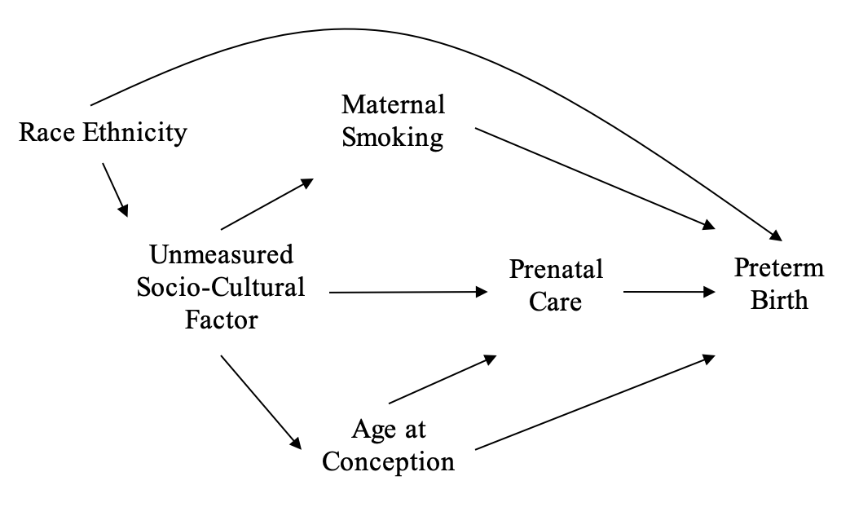
Figure 3. DAG illustrating pathways from prenatal care to preterm birth. Note: This DAG depicts the various pathways leading from prenatal care to preterm birth.

References

- Bhatnagar, S., Majumder, P. P., Salunke, D. M., & Interdisciplinary Group for Advanced Research on Birth Outcomes—DBT India Initiative (GARBH-Ini). (2019). A pregnancy cohort to study multidimensional correlates of preterm birth in India: study design, implementation, and baseline characteristics of the participants. American Journal of Epidemiology, 188(4), 621-631.
- Centers for Disease Control and Prevention. (2023, October 24). Preterm birth. Centers for Disease Control and Prevention. https://www.cdc.gov/reproductivehealth/maternalinfanthealth/pretermbirth.htm
- Leading health indicators. Leading Health Indicators - Healthy People 2030. (n.d.). https://health.gov/healthypeople/objectives-and-data/leading-health-indicators
- Thoma, M. E., Drew, L. B., Hirai, A. H., Kim, T. Y., Fenelon, A., & Shenassa, E. D. (2019). Black–White disparities in preterm birth: geographic, social, and health determinants. American journal of preventive medicine, 57(5), 675-686.
- Centers for Disease Control and Prevention. (2023a, September 13). Infant mortality. Centers for Disease Control and Prevention. https://www.cdc.gov/reproductivehealth/maternalinfanthealth/infantmortality.htm
- U.S. Department of Health and Human Services. (n.d.). What is prenatal care and why is it important?. Eunice Kennedy Shriver National Institute of Child Health and Human Development. https://www.nichd.nih.gov/health/topics/pregnancy/conditioninfo/prenatal-care
- Vintzileos AM, Ananth CV, Smulian JC, Scorza WE, Knuppel RA. The impact of prenatal care in the United States on preterm births in the presence and absence of antenatal high-risk conditions. Am J Obstet Gynecol. 2002;187(5):1254-1257.

